
NAME: MUDASSAR AHMAD

ROLL: SU92-BSDSM-S25-005

SUBJECT:AI(LAB)

SUBMITTED TO: SIR RASIKH

Table of Contents
Table of Contents 2
Introduction: 3
Objectives: 3
Tools and Technologies 3
Dataset Description 3
Methodology / Working 4
Code Implementation 4
data information 6

AI LAB TASK # 11

Introduction:
In this lab task, we performed data preprocessing on an insurance dataset using Python. Data preprocessing is an important step in machine learning that involves cleaning, transforming, and organizing raw data into a usable format.
The dataset contains information such as age, sex, BMI, smoker status, and insurance charges. The goal is to prepare this dataset for future machine learning models.

Objectives:
- To load and explore a dataset using Pandas
- To identify missing (null) values
- To clean and preprocess the data
- To convert categorical data into numerical form
- To prepare input (X) and output (Y) variables

Tools and Technologies
- Python
- Jupyter Notebook
- Libraries:
- Pandas
- NumPy

Dataset Description
The dataset used is insurance.csv, which contains:
- Age
- Sex
- BMI
- Children
- Smoker
- Region
- Charges
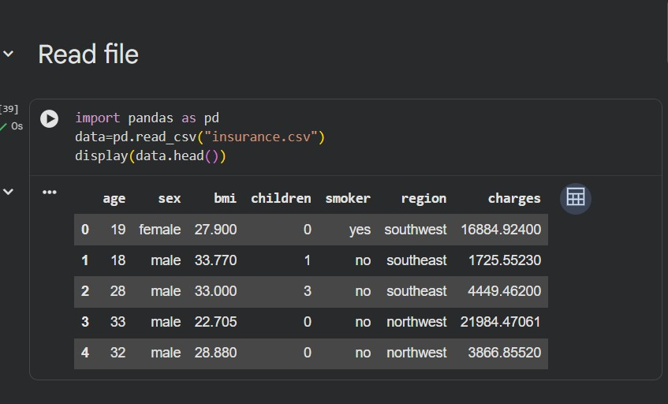

Methodology / Working
The program is divided into two classes:
- Pandas
- Numpy

Code Implementation

# Read file
"""

import pandas as pd
data=pd.read_csv("insurance.csv")
display(data.head())

"""# Shape of data"""

print("we have rows:{}".format(data.shape[0]),
"\n we have colunms:{}".format(data.shape[1]))

"""# Null values"""

import numpy as np
display(data.isnull().sum())
np.sum(pd.isnull(data))

"""# unique values in specific coulnms"""

display(data["smoker"].unique())
display(data["age"].unique())
display(data["sex"].unique())

"""# fill nulll values"""

num=data['smoker'].mode()[0]
data['smoker']=data["smoker"].fillna(num)
display(data["smoker"])

"""# covert to int"""

display(data.info())
data['bmi'] = data.bmi.astype(np.int64)
display(data.info())

"""drop **colunms**"""

data.drop("region" ,axis=1,inplace=True)
display(data.head())

"""data types of colunms"""

display(data.dtypes)

"""# spliting to x and y"""

x=data.iloc[:,0:-1]
x.shape
y=data.iloc[:,-1]
y.shape
display(data.shape)

"""# convert obj to int columns"""

c_columns=x.select_dtypes(['object']).columns
x[c_columns]=x[c_columns].apply(lambda x:pd.factorize(x)[0])

data information
